1 Create a user with the name Techie and provide sudo access to the user.
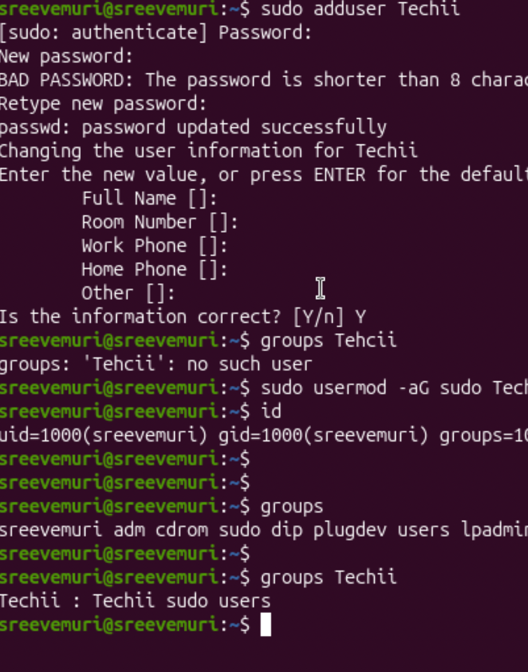
2 Navigate to the home directory.
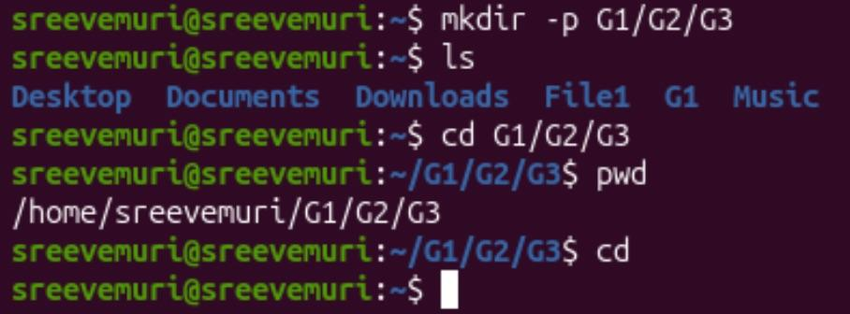
3 Create a new directory.
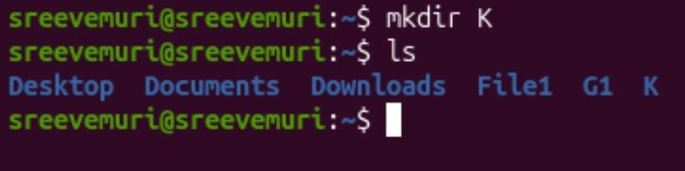
4 List the contents of a directory.
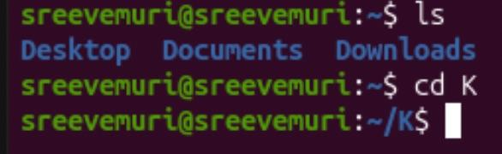
5 Change the current directory.
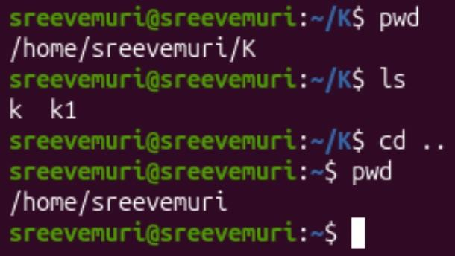
6 Create a new empty file.
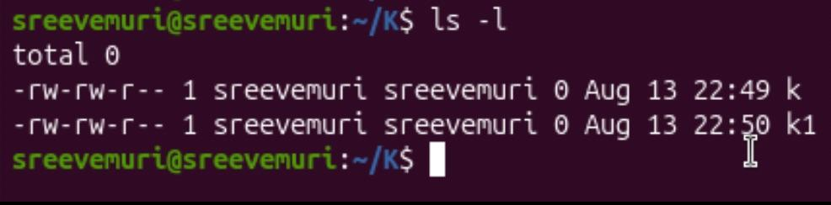
7 View the contents of a file.
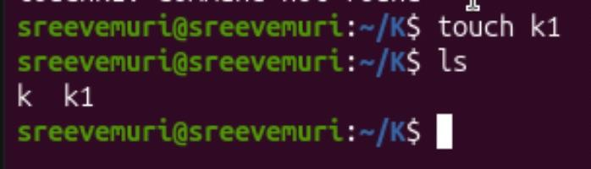
8 Copy a file to another location.
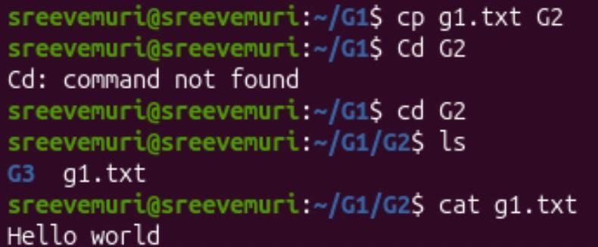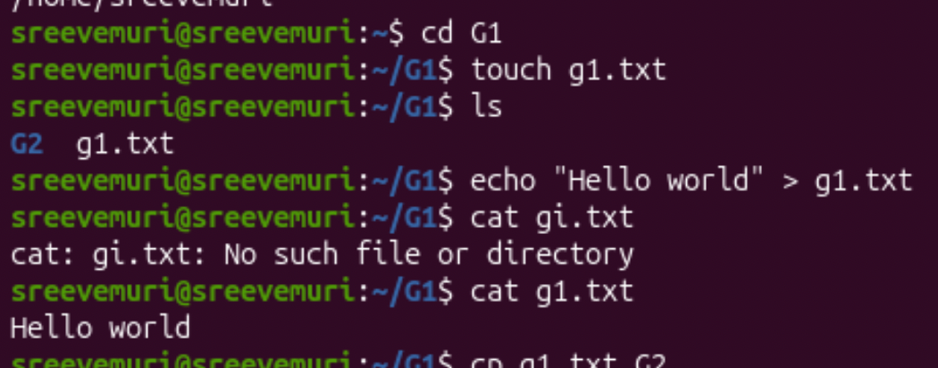

9 Move a file to another location.
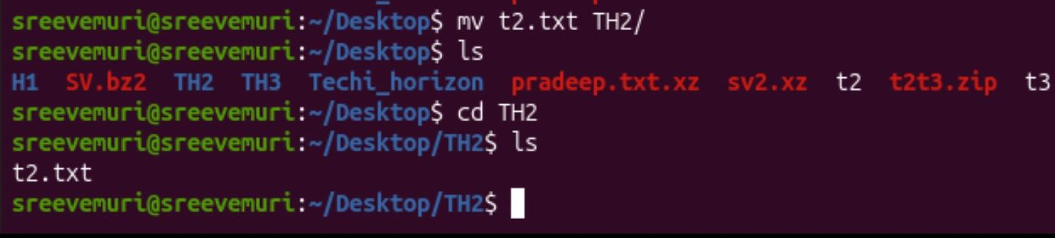

10 Rename a file.
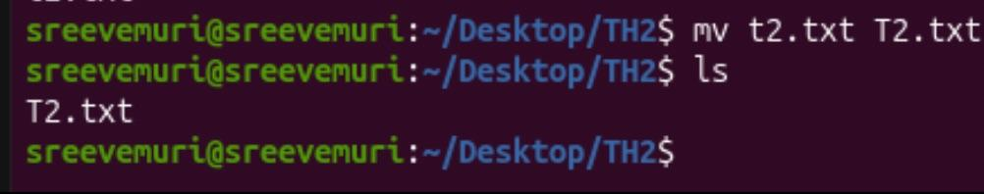
11 Delete a file.
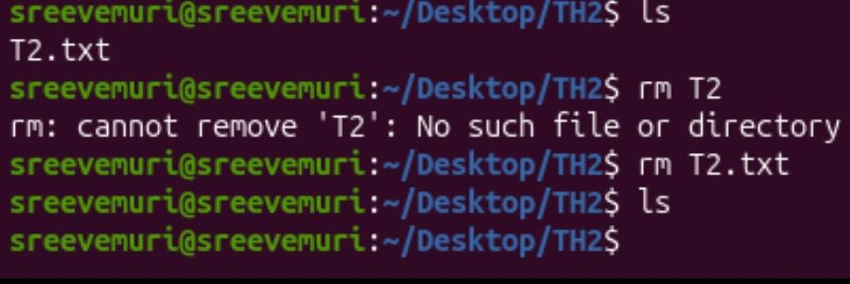
12 Grant or revoke permissions on a file or directory.
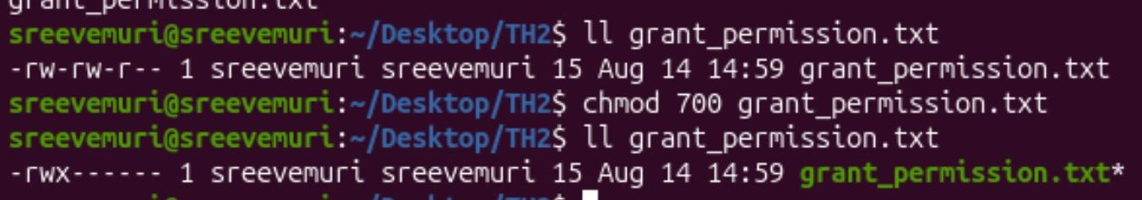

13 View the current date and time.
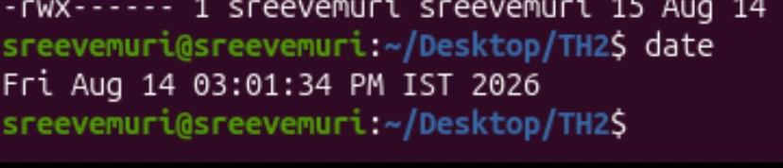
14 Check the system uptime.
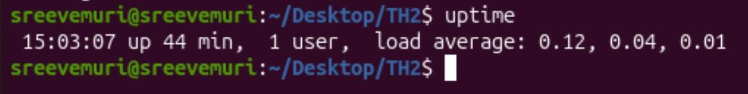
15 View the running processes.
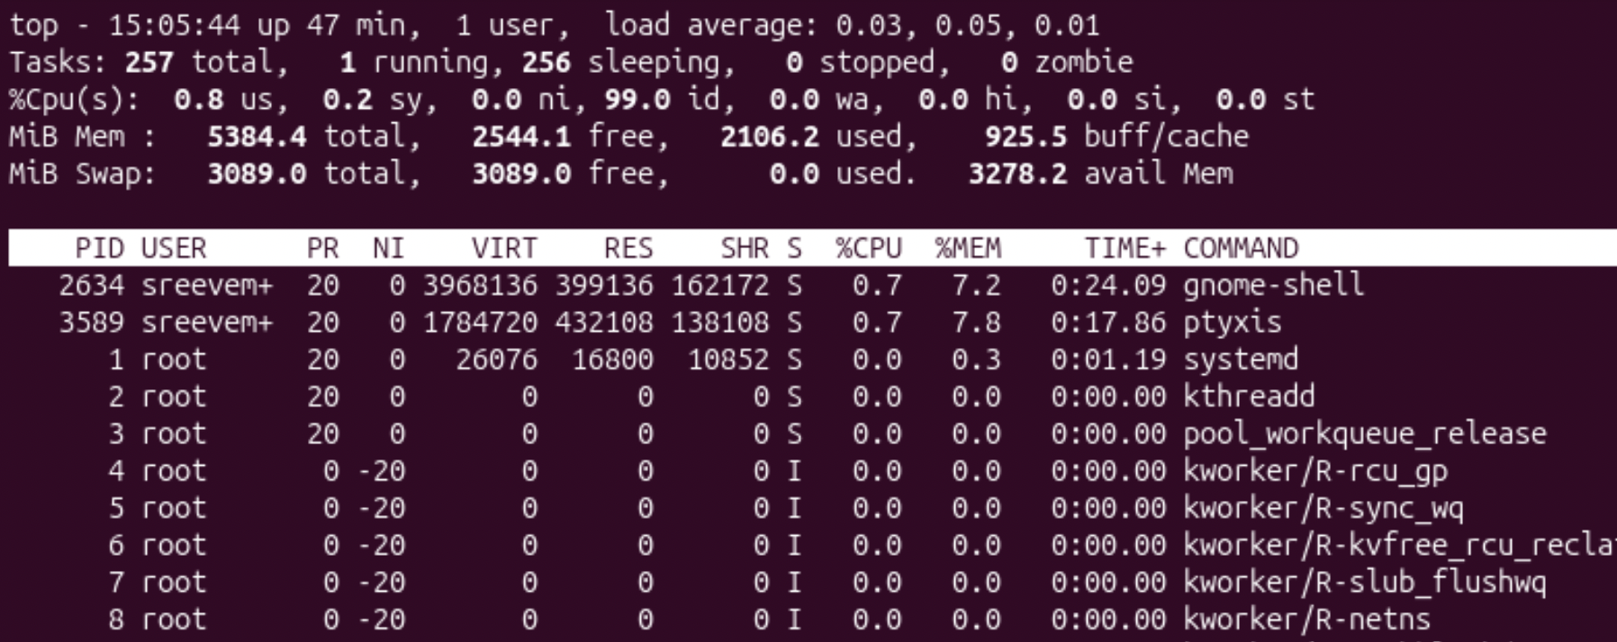
16 Kill a running process.
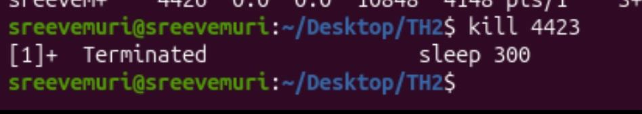
17 Install a package using the package manager (e.g., apt or yum).
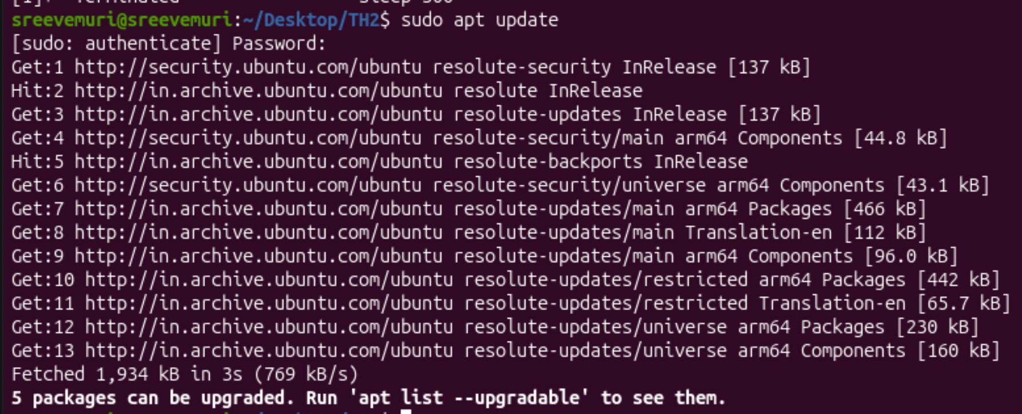
19 Create a symbolic link.
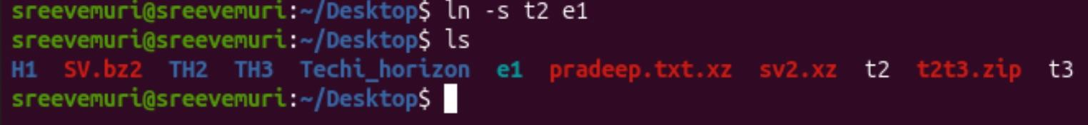
20 Search for files using the find command.
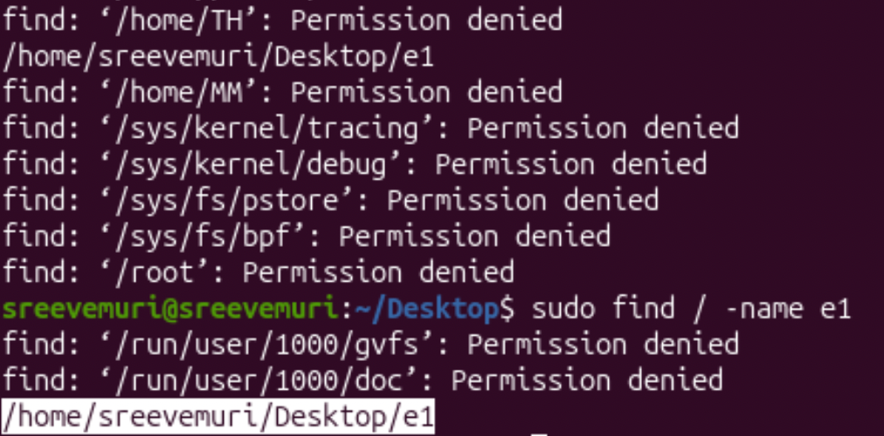

21. Compress and decompress files using tar.
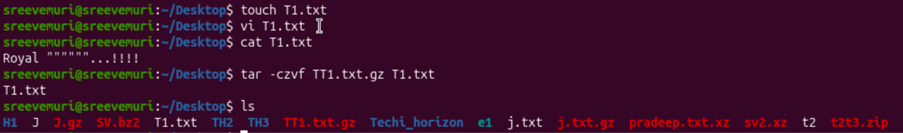
22 .Monitor system resources with top or h top.
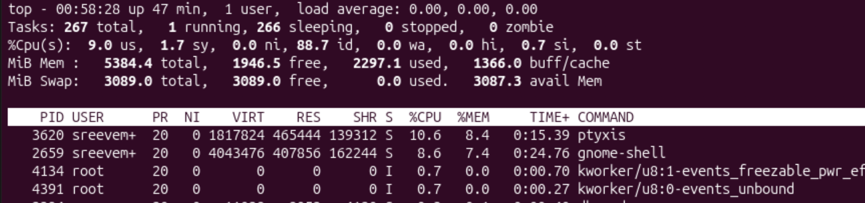
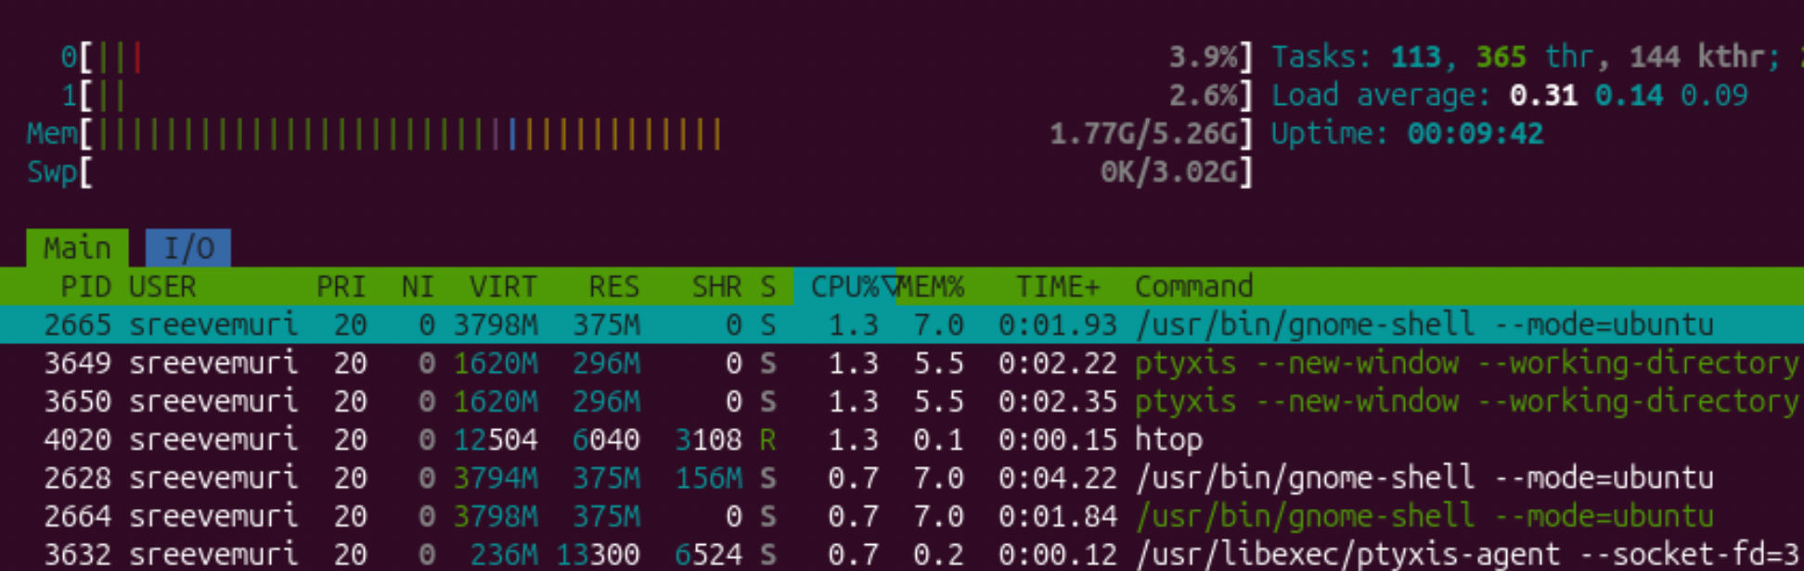
23. Create and manage user groups.
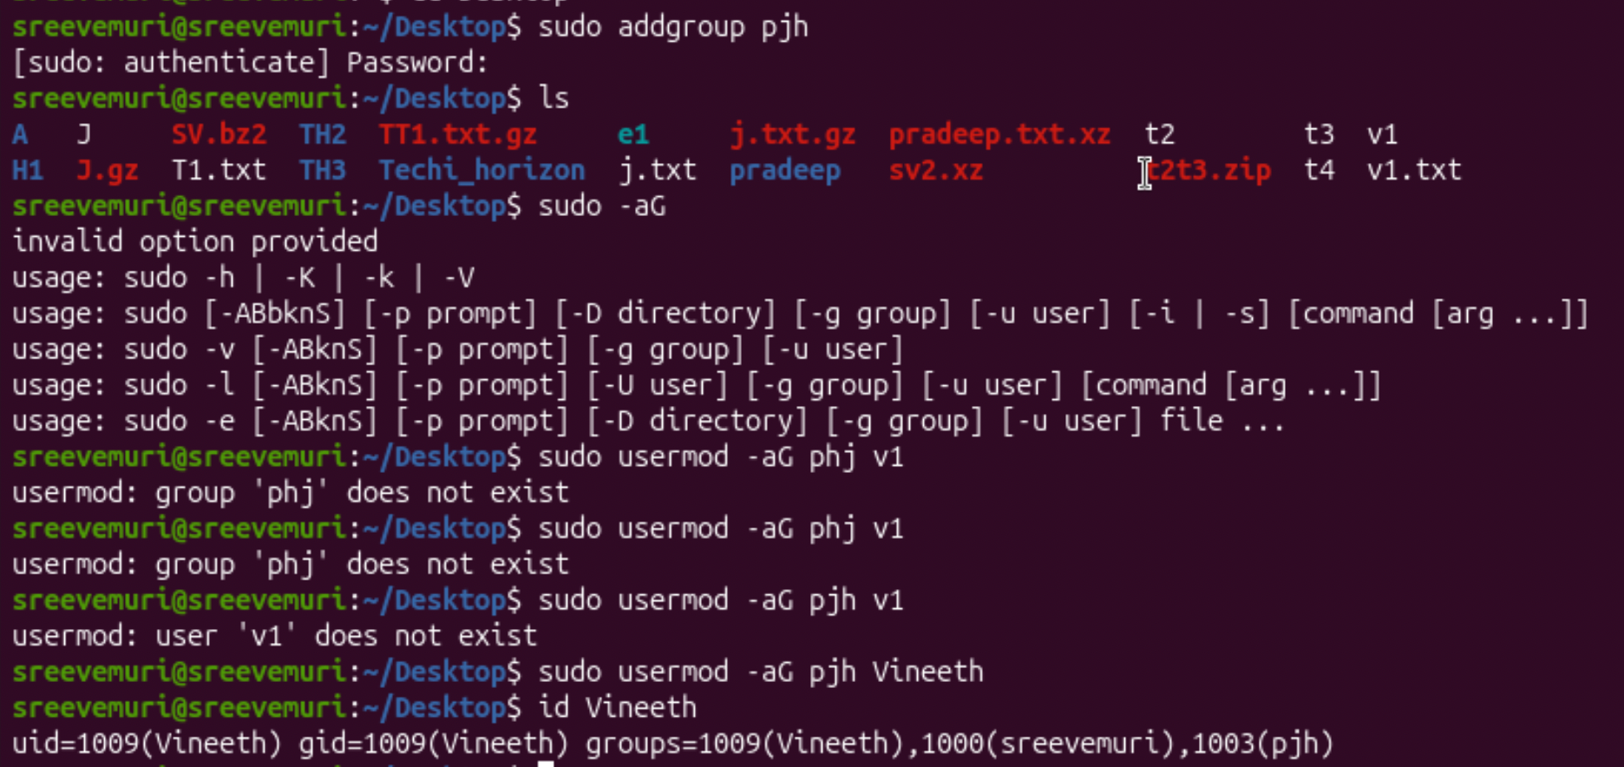
24. Set up SSH password less authentication.
25. Monitor log files using tail or grep.
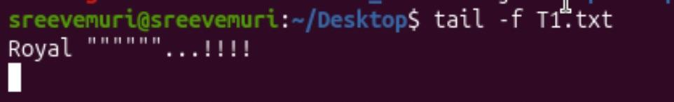
26. Set up a web server (e.g., Apache or Nginx).
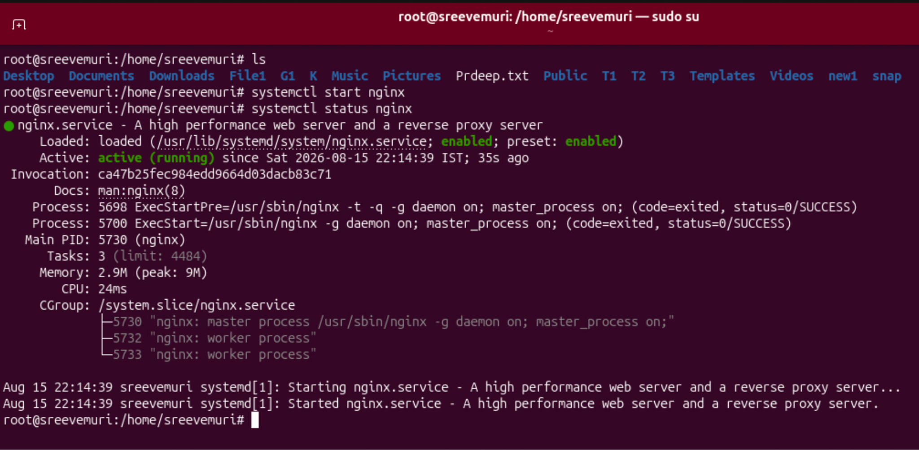
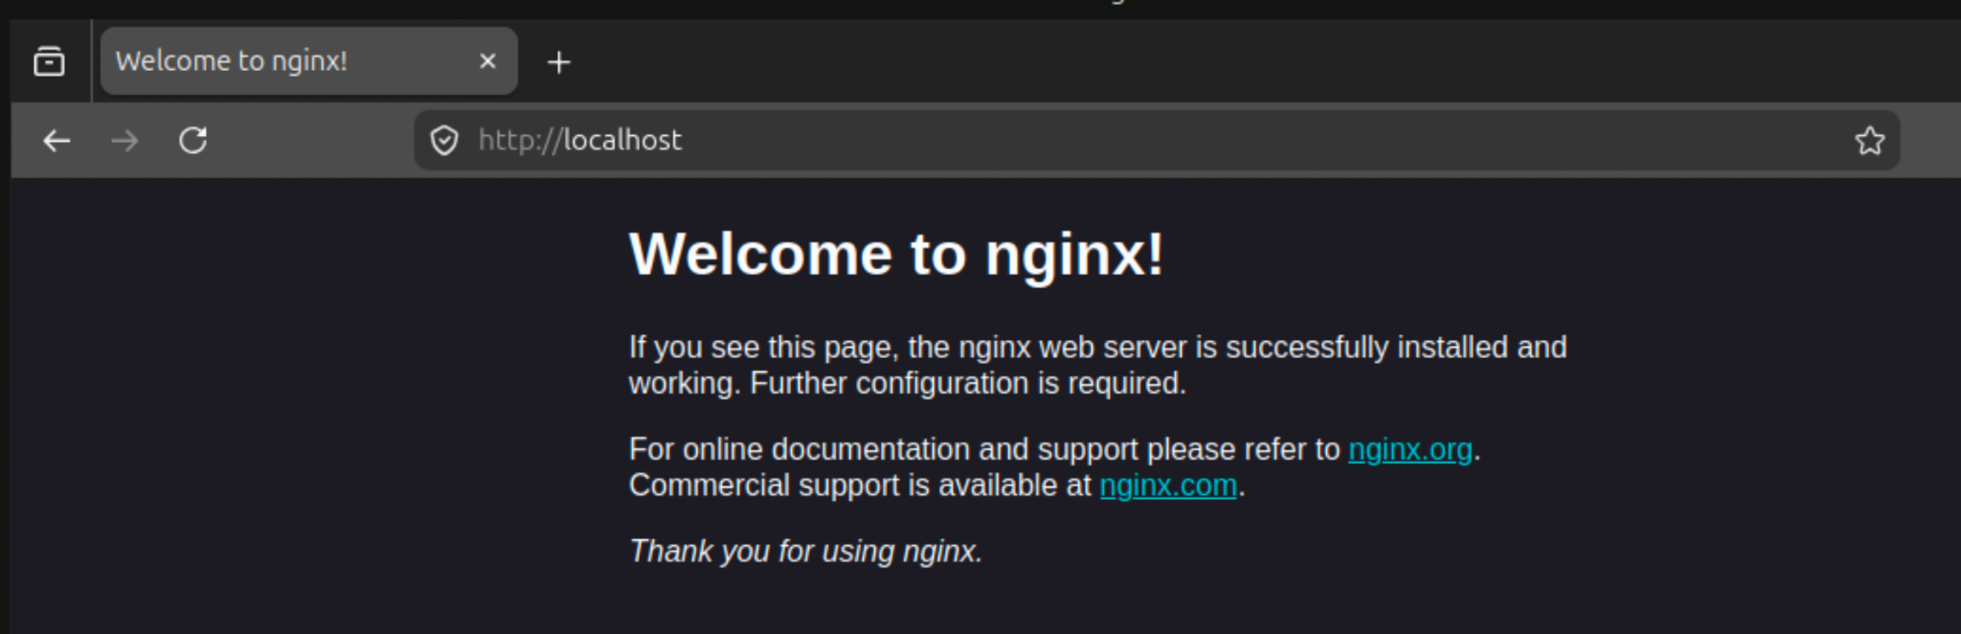
27. Configure and secure a MySQL Database.

28. Set up a Application Server (e.g.,Apache Tomcat)
